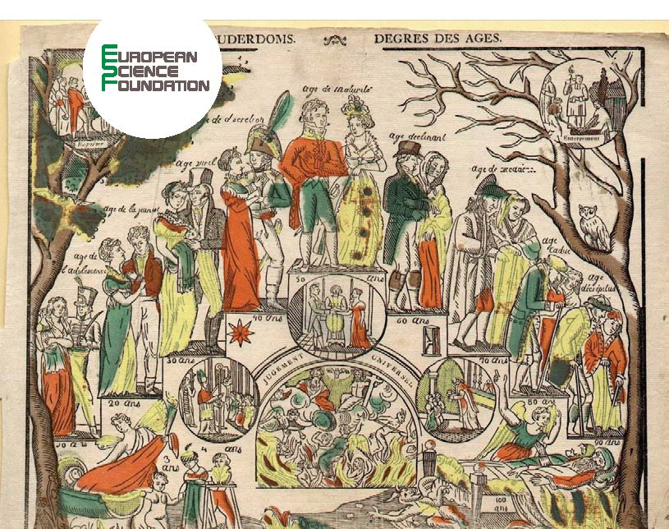

EHPS-Net – 2nd meeting

4-5 September 2012
Main building of Hungarian Central Statistical Office, Keleti Károly utca 5-7, Budapest
1st floor, room ’Kelet Károly’
+36 1 345-600

Schedule

Monday, 3 September

19:30 Dinner

Tuesday, 4 September
09:00 Welcome with coffee

09:15 Opening by Kees Mandemakers
Goals EHPS, program of today

09:30 Discussion working group 1 - Development Portal, see Appendix A (Report of the working group) – Coordinator: Kees Mandemakers

Chair: Peter Teibenbacher

a List of requirements
b Look and feel of the website
c Main questions (see also introduction report)
d Other questions

11:00 Break

11:15 Discussion working group 2 - E-journal Editorial Board, see Appendix B (report of the working group) – Coordinator: Koen Matthijs

Chair: Gunnar Thorvaldsen

12:45 Lunch

13:30 Discussion working group 3 - IDS Clearing Committee – Coordinator: Kees Mandemakers

Chair: Koen Matthijs

Presentation by Kees Mandemakers

14:00 Discussion working group 4 - Extraction software for IDS, see Appendix C (report of the working group) – Coordinator: Anders Brändström

a Identifying target groups and needs for extraction software
b Structure of extraction resources
c How, who and when?
d Other matters

Chair: Joshua Goldstein

15:30 Break

15:45 Discussion working group 5 - Looking into European and national call structures, developing proposals for historical micro data infrastructure – Coordinator: Joshua Goldstein

Chair: Ioan Bolovan

Presentation by Joshua Goldstein and Saskia Hin

17:15 Discussion working group 9 - GIS. Coordinator: Diego Ramiro

Chair: Michel Oris

18:45 End of first day

19:30 Dinner

Wednesday, 5 September

09:00 Welcome with coffee

09:15 Discussion working group 6 - New databases, see Appendix D1 (report of the working group) and D2 (Austria) - Coordinator: Gunnar Thorvaldsen

Chair: Anders Brändström

10:45 Break

11:00 Discussion working group 7 – Education - Coordinator: Alexander Buczynski

Chair: Lionel Kesztenbaum

12:30 Lunch

13:15 Discussion working group 8 - Standards for documentation about databases – Coordinator: Ólöf Garδarsdóttir

Chair: Alexander Buczynski

14:45 Next future (EHPS in 2012/2013)

Chair: Kees Mandemakers

a Working group structure (new groups, new members to existing groups)
b Wrapping up

16:00 End of meeting

16:30 Steering committee meeting

18:00 End of program

19:30 Dinner

